Initial user flow (version 1) - data entry

Prototyping week 1, Thursday 28 November 2019

In this folder you will find photos of the first proposed user flow relating to SOR data entry. The context of use is that the user has clicked create an SOR as new or from a copy and the “form” has opened. This flow covers from entering the information about a plant/FBO, to required roles and species, and ending with saving and very early ideas about distributing to various parties (FBO, Finance, MHIs/OVs/in-plant staff).

***Naming convention for photos is:***

***Version number - What it is (overview screen/discussion point/screen) - If page number appears this is the page number of the system - sequential feedback number.jpeg***

The flow was created in week 1 of prototyping and reviewed on Thursday with the following team members:

* Jonno
* Shaun
* Mark Deakin
* Stephen
* Jag
* Lowri

Questions, comments, things to address and improvements were added during the feedback session in purple.

Key:

* Technology opportunities in orange
* Inputs from the existing system in red
* New inputs in green
* Comments and feedback from group discussion are in purple

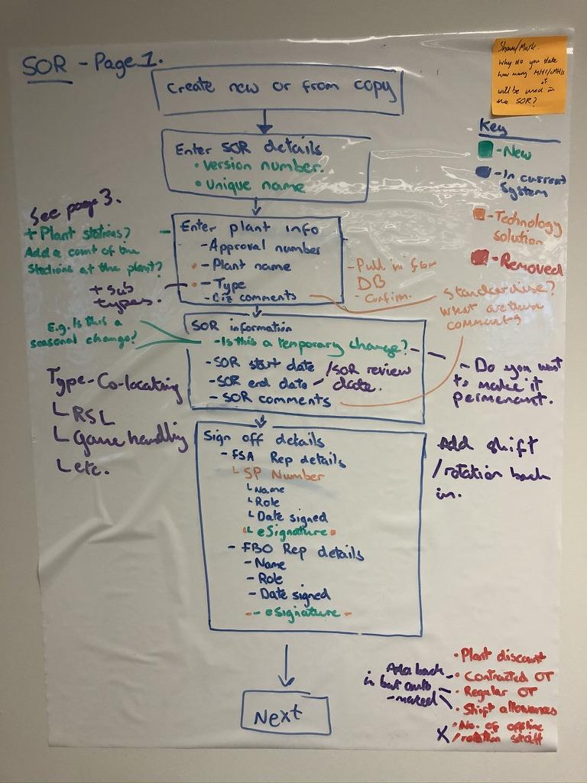

* As well as having a temporary change button/switch, we should include an option to make this permanent,
* Shift rotation should come back in as was taken out
* Language around the end date should change to be a “review” date - this will be friendly language for the ITL and FBO and will hopefully encourage reviews more often.
* Labels for contracted OT, regular OT and shift allowances should be put back in as non-editable labels.
* See page 3 - As well as capturing how many stations there are we should mark how many staff will be on off-line duties.

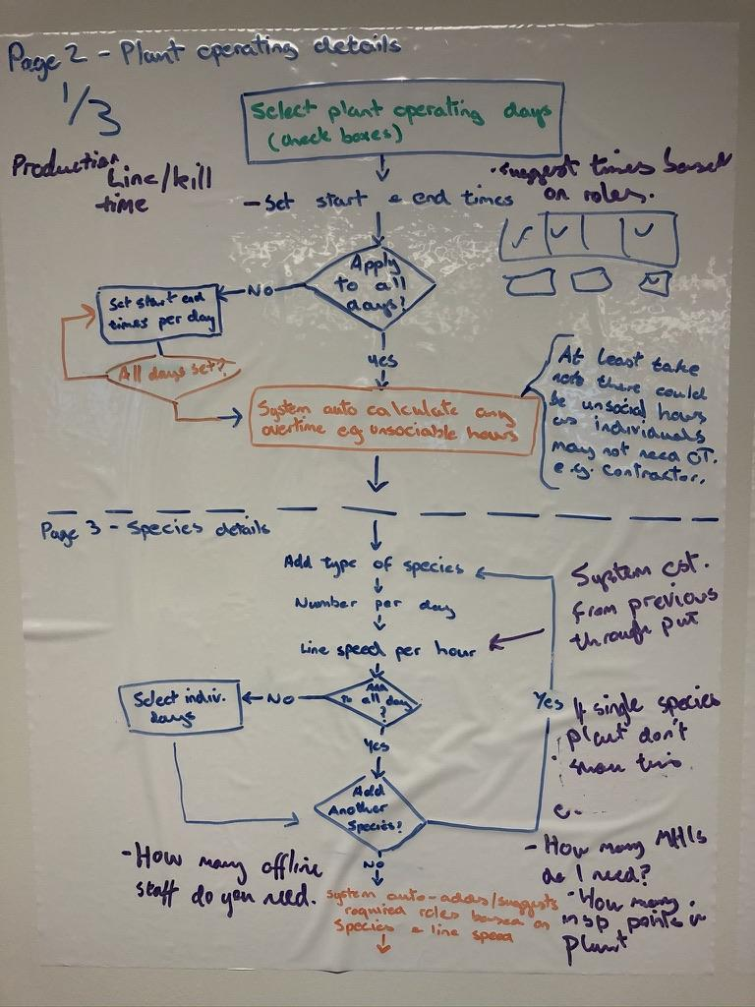

* The start and end hours/time relates on this page relates to when the line/kill begins and ends.  
  *This is a point to test with users. We are clarifying that this is going to be labelled kill time, will this make sense?*
* System to use business rules to calculate from the hours that are entered if OT will be flagged to the FBO.

**Page 3**

* The ordering here is important
* An estimate for line speed per hour can be given based on previous estimates.
* “Add another species” if it’s a single species plant then we don’t get the option to add another species
* Ask user “how many offline staff and how many inspection points are there in the plant to inform how many staff are needed.

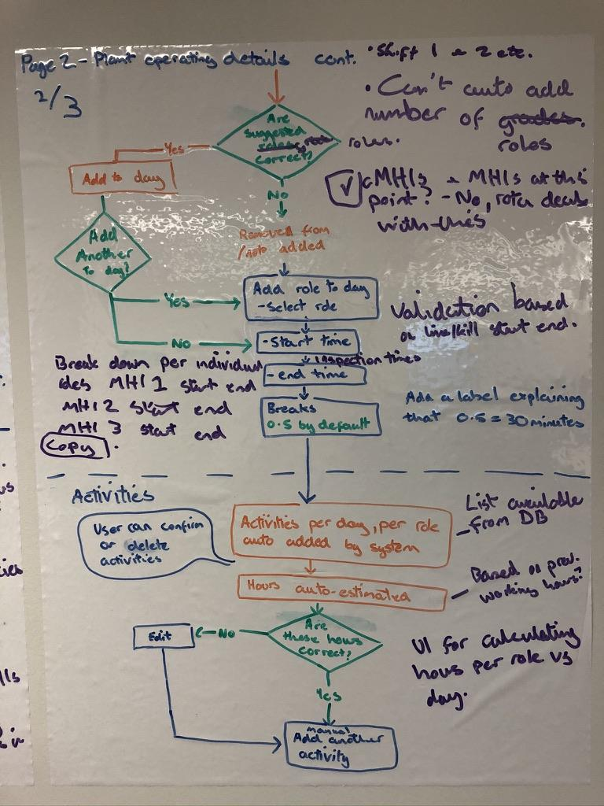

* Shift 1, 2 etc for multiple shifts
* We cannot auto-add the required number of roles needed.
* No need at the moment to specify cMHIs or MHIs
* Start and end times for roles - validation based on the line/kill start and end times.
* This is the inspection times - when that role should be on the line.
* Broken down into MHI 1, 2, 3’s start and end times.
* Activities per day, per role auto added by the system from a database - we know this is available.
* Hours auto-estimated based on previous working hours in this plant.
* UI required for calculating hours per role vs day.

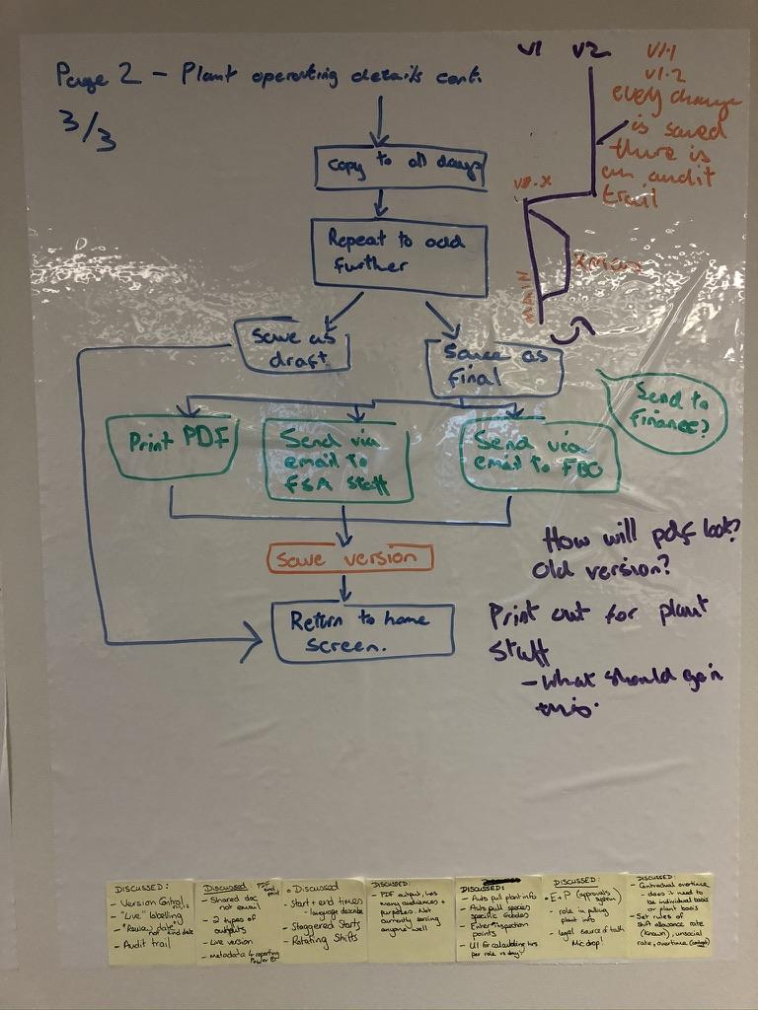

* How will PDF look? Like the old SOR?
* Print out for plant staff - what should go in this.

Version control - Example of thinking about how SOR system will track changes:

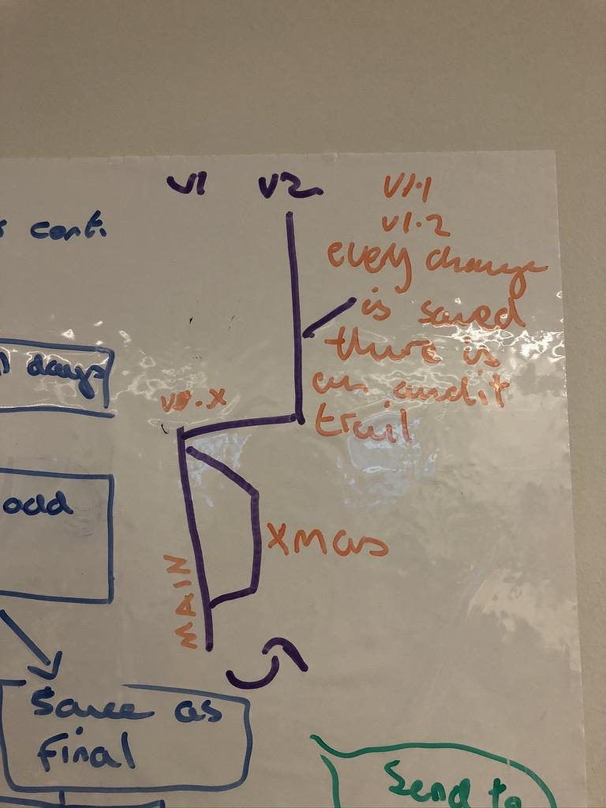

Best to think about this like a git version control system.

Changes will always be saved as a new version. This will be the main SOR. If there is a change to the SOR the ITL can specify if this is to be a temporary change, for example due to a Christmas increase in work. In this case, they will “flip a switch” and give the SOR a reflective name. They can put an end date/date to review with the FBO.

If the FBO wants to...:

* **change back to the previous** SOR they just flip this switch back and they are back to the main line.
* **keep this** current SOR they can update the review date, this will then branch into a new version of this temporary SOR.
* **make this the new permanent** SOR, they can switch this to be the main SOR. It will now be Version 2 (incremental change)



*The temporary change indication appears on page 1 off the SOR set-up.*